**Computer Organization & Architecture**

**Tutorial 3 [CO2]**

Q. 1 A computer uses a memory unit with 256K words of 32 bits each. A binary instruction code is stored in one word of memory. The instruction has four parts: an indirect bit, an operation code, a register code part to specify one of 64 registers, and an address part.

a. How many bits are there in the operation code, the register code part, and the address part?

b. Draw the instruction word format and indicate the number of bits in each part.

c. How many bits are there in the data and address inputs of the memory?

Q.2 what is the difference between a direct and an indirect address instruction?

How many references to memory are needed for each type of instruction tobring an operand into a processor register?

Q.3.The following control inputs are active in the bus system shown in Fig. 1

For each case, specify the register transfer that-will be executed during the

next dock transition.

|  |  |  |  |  |  |  |
| --- | --- | --- | --- | --- | --- | --- |
|  | S2 | S1 | S0 | LD of register | Memory | Adder |
| a | 1 | 1 | 1 | IR | Read | ---- |
| b | 1 | 1 | 0 | PC | ---- | ---- |
| c | 1 | 0 | 0 | DR | Write | ---- |
| d | 0 | 0 | 0 | AC | ---- | Add |

Q.4 The following register transfers are to be executed in the system of Fig.1

For each transfer, specify: (I) the binary value that must be applied to bus

select inputs S2, S1 and S0 (2) the register whose LD control input must be

active (if any); (3) a memory read or write operation (if needed)

a. AR🡨PC

b. IR🡨M[AR]

c. M[AR]🡨TR

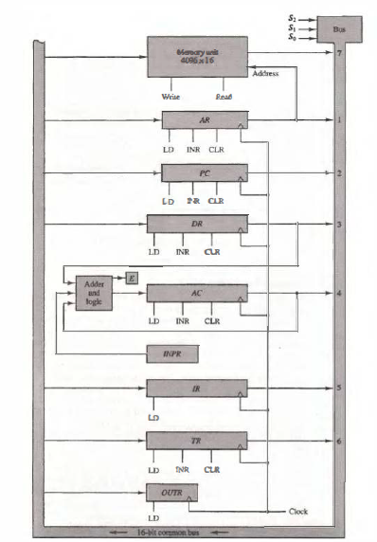

Figure 1

Q.5The system shown in Fig.2 uses a control memory of 1024 words of 32 bits each. The microinstruction has three fields as shown in the diagram. The

Micro-operations field has 16 bits.

1. How many bits are there in the branch address field and the select field?
2. If there are 16 status bits in the system, how many bits of the branch logic are used to select a status bit?
3. How many bits are left to select an input for the multiplexers?

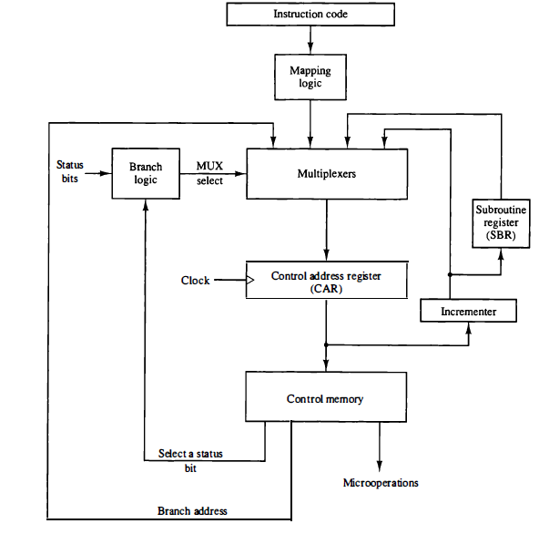

Figure 2

Q.6 Consider the instruction formats of the basic computer shown in Fig. 3 and

the list of instructions given in Table 1. For each of the following 16-bit instructions, give the equivalent four-digit hexadecimal code and explain inyour own words what it is that the instruction is going to perform.

a. 0001 0000 0010 0100

b. 1011 0001 0010 0100

c. 0111 0000 0010 0000

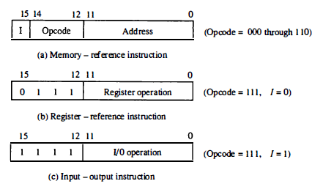

Figure 3

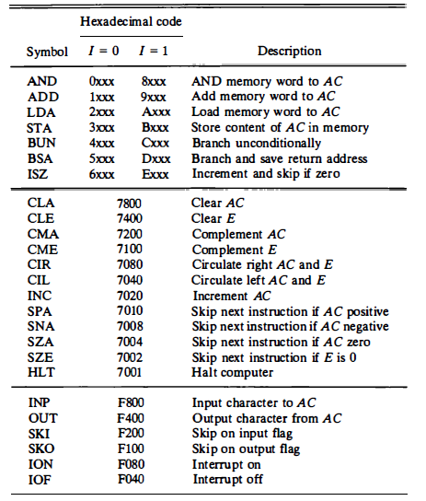

Table 1